*Web Design – HOME ASSIGNMENT*

Developing a responsive website

*Melaniya Micallef*

*Advanced Diploma in iGaming , Class AIG - 4.1A*

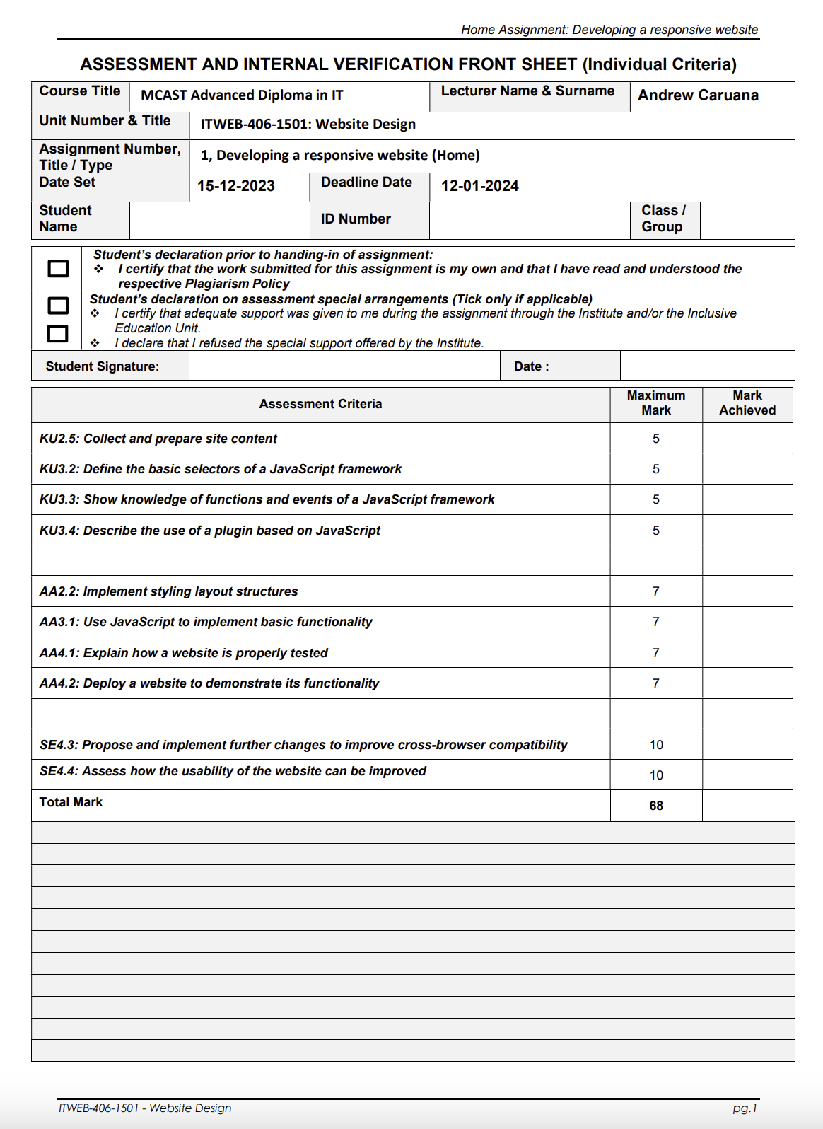

MEL 10/01/2024

Melaniya Micallef 189205(L) AIG 4.1A

**Table Of Contents**

**Section 1 - Plan & Design**

KU2.5 – Wireframes (tool used: figma)

**Section 2 – Implementation**

AA2.2 - AA2.2 – Implement styling layout structures.

AA3.1 – Use JavaScript to implement basic functionality.

KU3.2 – Define the basic selectors of a JavaScript framework.

KU3.3 – Show knowledge of functions and events of a JavaScript framework.

KU3.4 – Describe the use of a plugin based on JavaScript framework.

AA4.2 – Deploy a website to demonstrate its functionality.

SE4.3 – Propose and implement further changes to improve cross browser compatibility.

**Section 3 – Evaluation and Testing**

AA4.1 – Explain how a website is properly tested.

SE4.4 – Assess how the usability of the website can be improved.

# **Wireframes**

## Mobile

Tablet

## Desktop

# **Section 1 – Plan and Design.**

## KU2.5

Software Used:

Visual Studio Code: is an integrated development environment which will be used to implement this website. Html is a language made up of elements which will be used to develop the website and CSS is used to style it.

Adding to this JavaScript was used to make the pages more interactive, this is commonly used for dynamic changes and validations. jQuery is a library which is imported into the html code to make the JavaScript easier to use. Bootstrap is a technology used for modern websites which support JavaScript extensions.

# **Section 2- Implementation**

**AA2.2 - AA2.2 – Implement styling layout structures.**

Login / Register

Home Page

About us

Contact us.

Gallery of different games.

**AA3.1 – Use JavaScript to implement basic functionality.**

When the Login button is pressed a login form that accepts a username, and a password is displayed. When the login button is pressed an alert box saying “you are logged in” should be displayed and the user sent to the ‘Games’ screen.

**KU3.2 – Define the basic selectors of a JavaScript framework.**

**KU3.3 – Show knowledge of functions and events of a JavaScript framework.**

Images in the ‘Games’’ section, must have a “try me” button with an ‘onclick’ event. Once the button is clicked, a window or tab with a relevant background should open.

**

## **KU3.4 – Describe the use of a plugin based on JavaScript framework.**

Set Up Bootstrap:

Ensure you have a working HTML file with Bootstrap linked. You can link Bootstrap via CDN by adding this line in the <head> section of your HTML file.

Structure the HTML:

Create the structure for the gallery within the <body> section of your HTML file.

Add Images:

Include the images inside the #image-gallery div.

Ensure to replace image1.jpg, Casino Image 1, and adjust the number of columns (col-md-4 col-sm-6) as per your layout preference.

You can add additional CSS to customize the gallery appearance, like adjusting image sizes, margins, or borders.

Preview your gallery in a web browser. Ensure all images are displayed properly and the layout looks good across different devices.

**AA4.2 – Deploy a website to demonstrate its functionality.**

**SE4.3 – Propose and implement further changes to improve cross browser compatibility.**

# **Section 3 – Evaluation and Testing**

## **AA4.1 – Explain how a website is properly tested.**

Test Case 1:

Test Case 2:

# **Validate work using https://validator.w3.org/.**

### HTML page

### CSS Page

# **SE4.4 – Assess how the usability of the website can be improved.**

Throughout this assignment, I have gained a deeper understanding of JavaScript and its libraries, including jQuery. Initially, I began implementing certain tags and codes in a particular way, but later discovered a more intricate approach. The outcome of this assignment left me feeling content and satisfied. Moving forward, there are several enhancements that can be implemented to provide users with a more interactive website experience. For instance, clicking on a game could redirect users to the actual game, while also offering them the opportunity to create an account and select a character. Additionally, incorporating a section to track winnings in terms of money and tokens would further enhance user engagement. As I continue to learn about this subject, I acknowledge that there is room for improvement, especially with more time allocated. Furthermore, clicking on a game could result in a different background being displayed each time, catering to various electronic devices, and ensuring all content is visible.